

**SUBMITTED BY : *Dheer Banker***

**GROUP : *Dheer Banker* *and aaaaavvviiiiDev Radadia***

**CLASS :** ***XII (Science)***

**BATCH : *2020-21***



**SUBMITTED TO :** ***Honey Shivnani***

**COMPUTER PROJECT**

**ON**

**“PYGAME”**



***SHIV ASHISH SCHOOL***

***Index***

* Certificate
* Acknowledgement
* Python Introduction
* System Requirements
* Game Logo
* Project Overview
* Procedural Design
* Modules Used
* Functions Used
* Source Code
* Screenshots
* Limitations
* Bibliography



CERTIFICATE

*This is to certify that_________________________, a student of Class XII Science has successfully completed the research on the Computer Science project titled by __________________________________ under the guidance of ____________________Mrs. Honey Shivnani at Shiv Ashish School, Ahmedabad, Gujarat during the year 2020-21.*

PHOTO

**TEACHER IN-CHARGE PRINCIPAL**

***Acknowledgement***

*We would like to express our special thanks of gratitude to our teacher HONEY SHIVNANI as well as our principal DIKSHA DAVE, who gave us the golden opportunity to do this wonderful project on PYGAME which also helped us in doing a lot of research and we came to know about so many new things. We are really thankful to them.*

*Secondly, we would also like to thank our parents and friends who helped us a lot in finalizing this project within the limited time frame.*

***Python Introduction***

* **What is Python?**

**Python is a popular programming language. It was created by Guido van Rossum, and released in 1989.**

***Interesting fact* : Python is named after the comedy television show “Monty Python’s Flying Circus”. It is not named after the Python snake.**

**It is used for :**

* web development (server-side),
* software development,
* mathematics,
* system scripting,
* data analysis,
* game development,
* desktop applications
* **What can Python do?**
* Python can be used on a server to create web applications.
* Python can be used alongside software to create workflows.
* Python can connect to database systems. It can also read or modify files.
* Python can be used to handle big data and perform complex problems.
* Python can be used for rapid prototyping, or for production-ready software development.
* **Why Python?**
* Python works on different platforms (Windows, Mac, Linux, etc.)
* Python has a simple syntax similar to the English language.
* Python has syntax that allows developers to write programs with fewer lines than some other programming languages.
* Python runs on an interpreter system, meaning that code can be executed as soon as it is written. This means that prototyping can be very quick.
* Python can be treated in a procedural way, an object-oriented way or a functional way.
* **Python Syntax compared to other programming languages**
* Python was designed for readability, and has some similarities to the English language with influence from mathematics.
* Python uses new lines to complete a command, as opposed to other programming languages which often use semicolons or parentheses.
* Python relies on indentation, using whitespace, to define scope; such as the scope of loops, functions and classes. Other programming languages often use curly-brackets for this purpose.
* **Python-Pluses**

1. Easy to Use
2. Expressive Language
3. Interpreted Language
4. Free and Open Source
5. Cross-Platform Language
6. Extensive Libraries
7. Object-Oriented Language
8. Improvised Productivity
9. Advanced features
10. Automatic memory management

* **Python-Minuses (So Human Like)**

1. Not the Fastest Language
2. Lesser Libraries than C, Java, Perl
3. Not Strong on Type­Binding
4. Not Easily Convertible
5. High Memory Consumption
6. Weak in Mobile Development
7. Underdeveloped Database Access Layers

***System Requirements***

* **Hardware Requirements**
* *Operating System* : Supports Linux, Windows (95, 98, ME, 2000, XP, Vista, 64-bit Windows), Windows CE, BeOS, aaaaaaaaaaaaadddaMacOS, Mac OS X, FreeBSD, NetBSD, OpenBSD, aaaaaaaaaadddaaaaBSD/OS, Solaris, IRIX, and QNX
* *RAM* : 500MB
* *Graphics Card* : AMD Radeon HD 5450
* *CPU* : Intel Pentium 4 2.00GHz
* *HDD Space* : 50MB
* **Software Requirements**
* *IDE* : A Python IDE (eg. Python IDLE, Spyder, Pycharm, Atom, etc.)
* *Python Modules* : Pygame, Numpy, Random, Math and Datetime

***Game Logo***



### *Project Overview*

PingPong - A project made by Dev Radadia and Dheer Banker

The aim of the project is to create a ping-pong game with two game-modes – ‘1 Player’ and ‘2 Players’ with a smooth, intuitive gameplay.

* ***Salient Features* :**

1. The project is divided into 6 packages :
   1. ***ai*** – Contains the code governing the AI used in 1 player game-aaaamode
   2. ***image*** – Contains the images used in the project
   3. ***r*** – Contains the screen-wise strings, resources and font styles used addin the project
   4. ***screens*** – Contains the code governing every screen in the project, aaaaaaaaawith a module for every screen
   5. ***sound*** – Contains the sounds used in the project
   6. ***sprites*** – Contains the different pygame drawables that have been aaaaaddaused in the project
2. All the GUI Elements in the project are developed solely using pygame from scratch, in order to keep the GUI consistent throughout the application.
3. The project also includes various sounds in it, which are played when a button is clicked, or when the ball bounces with the paddle or the wall.
4. There are a total of 6 screens in the project :
   1. ***About*** – Tells the user about the developers and the basic controls aaaaaaaaof the game
   2. ***Main*** ***Menu*** – The main screen that has options to go to the other aaaaadddaaaaascreens
   3. ***PlayerNames*** – The screen where players can enter their names aaaaaaaaaaaaaaaand choose their paddle colours
   4. ***Game*** – The game screen, where the players can play
   5. ***Pause*** – The screen which comes up when the game is paused, by aaaaaaaapressing ***Pause button*** or by pressing ***P***
   6. ***EndGame*** – The screen which declares the winner of the game aaaaaddddddthat was just played
5. Finally, all the screens are bound together by the controller code “***The Game.py***”.

***Procedural Design***

1. To start the application, click on **The Game.py** or run **The Game.py** via a Python console.
2. The main screen appears, which has three options :
   1. **Start** : Takes the user to the **Player Names** screen (details ddddaamentioned below).
   2. **About** : Takes the user to the **About** screen, which contains aaaaaaaainformation about the project and its basic controls.
   3. **Quit** : Exits the application.
3. **Player Names** screen : Here, the players can set their respective names aaaaaaaaaaaaaaaaadddaand choose their colours (default White). From aaaaaaaaaaaaaaadaaaddhere they can either **Return to Main Menu** or aaaaaaaaaaaaaaaddaaadpress **Enter** to move to the **Game** screen.
4. **Game** screen : After an initial countdown from 3 to 1, the game starts.

Players can :

* + - * 1. move their paddles using the respective controls (mentioned in **About** screen)
        2. pause the game using the ***Pause button*** or by pressing ***P***
        3. go to the main screen by pressing ***Esc***

1. **Pause** screen : Shows the current scores and has the options to **Resume, aaaaaaaaaaaaReturn to Main Menu** or **Quit**.
2. **Endgame** screen : The screen which follows when the game ends, aaaaaaaaaadaaaaadshowing the winner’s name, and the options to **Play aaaaaaaaaaaaaddAgain, Return to Main Menu,** or **Quit**.

***The possible screens and transitions are shown in the image below***

***Modules Used***

*User-defined Modules*

1. ai.fnn
2. ai.functions
3. ai.qlearner
4. r.about
5. r.colors
6. r.db_info
7. r.endgame
8. r.font_size
9. r.game
10. r.main
11. r.pause
12. r.playernames
13. screens.about
14. screens.endgame
15. screens.game
16. screens.main_menu
17. screens.pause
18. screens.playernames
19. sprites.Ball
20. sprites.Border
21. sprites.Button
22. sprites.Label
23. sprites.Paddle
24. sprites.PauseButton
25. sprites.Textbox

*Built-In Modules*

1. pygame
2. numpy
3. random
4. math
5. datetime

***Functions Used***

1. main
2. start_menu
3. player_details
4. start_game
5. pause_game
6. launch_endgame
7. launch_about
8. initiateConnection
9. createDatabase
10. saveGameInstance
11. compute_oup
12. reset
13. setBias
14. setWeights
15. f
16. fp
17. updateIntent
18. quadraticCostDerivative
19. createBrainArray
20. loadMemory
21. getIntent
22. __init__
23. show_menu
24. showAbout
25. setAboutText
26. setDisplay
27. PlayerNames
28. handleColorClick
29. getPlayer1Name
30. getColor1
31. getPlayer2Name
32. getColor2
33. setColorButtons
34. playersReset
35. gameReset
36. collides
37. play
38. countdown
39. setGameObjective
40. setMovables
41. setPaddleMargin
42. setPaddleSpeed
43. setBallResetMargin
44. setBounceBias
45. setPlayer1Name
46. setPlayer2Name
47. setBounceAcceleration
48. setPlayerColors
49. getWinnerColor
50. getWinnerName
51. getLoserName
52. getScores
53. getFinalScores
54. pause_game
55. setScores
56. setWinnerColor
57. setWinnerName
58. showEndScreen
59. bounce
60. same_dir
61. crossed
62. ballReset
63. update
64. setResetMargin
65. setBallSpeed
66. getXSpeed
67. moveUp
68. moveDown
69. rectangle
70. draw
71. test_surface
72. image
73. rect
74. setHighlightable
75. stayHighlighted
76. staysHighlighted
77. getTextRgb
78. handle_event
79. define_event
80. getText
81. setText

***Source Code***

***The Game.py***

import pygame

from datetime import datetime

from enum import Enum

import r

import screens

import mysql.connector as scon

def main():

global game, main_menu, player_names, pause_screen, endgame_screen, about_screen, db_con

pygame.mixer.pre_init(22050, -16, 1, 512)

pygame.init()

pygame.mixer.quit()

pygame.mixer.init(22050, -16, 1, 512)

pygame.display.set_caption(r.main.r_title_label_txt)

default_bg=pygame.image.load("image\\bg_default.jpg")

screen = pygame.display.set_mode((r.game.SCREEN_WIDTH, r.game.SCREEN_HEIGHT), pygame.FULLSCREEN)

game_screen = Screen.MENU

game=screens.game.GameScreen(screen, (r.game.SCREEN_WIDTH, r.game.SCREEN_HEIGHT), r.colors.BLACK, r.colors.WHITE, r.game.SCORE_MARGIN, r.game.FPS)

game.setPaddleMargin(r.game.PADDLE_MARGIN)

game.setPaddleSpeed(r.game.PADDLE_SPEED)

game.setBallResetMargin(r.game.BALL_RESET_Y_MARGIN)

game.setBounceBias(r.game.PADDLE_BOUNCE_BIAS)

game.setBounceAcceleration(r.game.BALL_BOUNCE_ACC)

game.setGameObjective(r.game.game_obj_txt)

game.setMovables(r.game.BALL_HEIGHT, (r.game.PADDLE_WIDTH, r.game.PADDLE_HEIGHT), r.colors.WHITE, r.colors.WHITE)

main_menu=screens.main_menu.MainMenuScreen(screen, r.main.r_title_label_txt, (r.game.SCREEN_WIDTH, r.game.SCREEN_HEIGHT), r.colors.BLACK, r.colors.WHITE, bg=default_bg)

player_names=screens.playernames.PlayerNamesScreen(screen, r.playernames.playernames_label_txt, r.playernames.p_label_txt, r.playernames.ai_label_txt, r.playernames.p1_label_txt, r.playernames.p2_label_txt, r.playernames.name_label_txt, (r.game.SCREEN_WIDTH, r.game.SCREEN_HEIGHT), r.colors.BLACK, r.colors.WHITE, bg=default_bg)

pause_screen=screens.pause.PauseScreen(screen, r.pause.paused_label_txt, (r.game.SCREEN_WIDTH, r.game.SCREEN_HEIGHT), r.colors.BLACK, r.colors.WHITE, bg=default_bg)

endgame_screen=screens.endgame.EndgameScreen(screen, r.endgame.win_statement, (r.game.SCREEN_WIDTH, r.game.SCREEN_HEIGHT), r.colors.BLACK, bg=default_bg)

about_screen=screens.about.AboutScreen(screen, r.about.text_about, (r.game.SCREEN_WIDTH, r.game.SCREEN_HEIGHT), r.colors.BLACK, r.colors.WHITE, bg=default_bg)

initiateConnection()

while True:

if game_screen == Screen.MENU:

game_screen = start_menu(screen)

if game_screen == Screen.PLAYER1:

game_screen = player1_details(screen)

if game_screen == Screen.PLAYERS2:

game_screen = players2_details(screen)

if game_screen == Screen.PLAYGAME:

Start_Time = datetime.now().strftime("%H:%M:%S")

game_screen = start_game(screen, game)

if game_screen == Screen.PAUSE:

game_screen = pause_game(screen)

if game_screen == Screen.ENDGAME:

Date = datetime.now().strftime("%Y-%m-%d")

End_Time = datetime.now().strftime("%H:%M:%S")

Winner = game.getWinnerName()

Loser = game.getLoserName()

Winner_Score, Loser_Score = game.getFinalScores()

saveGameInstance(Date, Start_Time, End_Time, Winner, Winner_Score, Loser, Loser_Score)

game_screen = launch_endgame(screen)

if game_screen == Screen.ABOUT:

game_screen = launch_about(screen)

if game_screen == Screen.QUIT:

db_con.close()

pygame.quit()

return

def start_menu(screen):

new_screen=main_menu.show_menu()

game.gameReset()

if new_screen == screens.main_menu.CB_QUIT:

return Screen.QUIT

if new_screen == screens.main_menu.CB_1PLAYER:

return Screen.PLAYER1

if new_screen == screens.main_menu.CB_2PLAYERS:

return Screen.PLAYERS2

if new_screen == screens.main_menu.CB_ABOUT:

return Screen.ABOUT

return Screen.QUIT

def player1_details(screen):

new_screen=player_names.Player1_Name()

if new_screen == screens.playernames.CB_PLAY_AI:

game.setPlayer1Name(player_names.getPlayer1Name())

game.setPlayer2Name(player_names.getPlayer2Name())

game.enableAi()

game.setMovables(r.game.BALL_HEIGHT, (r.game.PADDLE_WIDTH, r.game.PADDLE_HEIGHT), player_names.getColor1(), player_names.getColor2())

return Screen.PLAYGAME

if new_screen == screens.playernames.CB_RETURN:

return Screen.MENU

return Screen.QUIT

def players2_details(screen):

new_screen=player_names.Players2_Names()

if new_screen == screens.playernames.CB_PLAY:

game.setPlayer1Name(player_names.getPlayer1Name())

game.setPlayer2Name(player_names.getPlayer2Name())

game.setMovables(r.game.BALL_HEIGHT, (r.game.PADDLE_WIDTH, r.game.PADDLE_HEIGHT), player_names.getColor1(), player_names.getColor2())

game.disableAi()

return Screen.PLAYGAME

if new_screen == screens.playernames.CB_RETURN:

return Screen.MENU

return Screen.QUIT

def start_game(screen,game):

new_screen = game.play()

if new_screen == screens.game.CB_PAUSE:

return Screen.PAUSE

elif new_screen == screens.game.CB_ENDGAME:

return Screen.ENDGAME

elif new_screen == screens.game.CB_RETURN:

return Screen.MENU

elif new_screen == screens.game.CB_QUIT:

return Screen.QUIT

return Screen.MENU

def pause_game(screen):

global game,pause_screen

pause_screen.setScores(game.getScores())

new_screen = pause_screen.pause_game()

if new_screen == screens.pause.CB_QUIT:

return Screen.QUIT

if new_screen == screens.pause.CB_PLAY:

return Screen.PLAYGAME

if new_screen == screens.game.CB_RETURN:

return Screen.MENU

return Screen.MENU

def launch_endgame(screen):

global endgame_screen,game

endgame_screen.setWinnerName(game.getWinnerName())

endgame_screen.setWinnerColor(game.getWinnerColor())

new_screen=endgame_screen.showEndScreen()

if new_screen==screens.endgame.CB_PLAY:

return Screen.PLAYGAME

if new_screen==screens.endgame.CB_RETURN:

return Screen.MENU

if new_screen == screens.pause.CB_QUIT:

return Screen.QUIT

return Screen.MENU

def launch_about(screen):

global about_screen

new_screen=about_screen.showAbout()

if new_screen==screens.about.CB_RETURN:

return Screen.MENU

if new_screen==screens.about.CB_QUIT:

return Screen.QUIT

return Screen.MENU

def initiateConnection():

global db_con

try:

db_con=scon.connect(host=r.db_info.HostName, user=r.db_info.UserName, passwd=r.db_info.Password, database=r.db_info.DatabaseName)

except scon.errors.ProgrammingError:

print("No database found, initiating it now")

createDatabase()

finally:

db_con=scon.connect(host=r.db_info.HostName, user=r.db_info.UserName, passwd=r.db_info.Password, database=r.db_info.DatabaseName)

def createDatabase():

db=scon.connect(host=r.db_info.HostName, user=r.db_info.UserName, passwd=r.db_info.Password)

db.cursor().execute(r.db_info.Q_CREATE_PONGDATA)

db=scon.connect(host=r.db_info.HostName, user=r.db_info.UserName, passwd=r.db_info.Password, database=r.db_info.DatabaseName)

db.cursor().execute(r.db_info.Q_CREATE_GAMESTATS)

db.close()

def saveGameInstance(date, startTime, endTime, winnerName, winnerScore, loserName, loserScore):

global db_con

query=r.db_info.Q_ADD_GAME_DATA.format(date, startTime, endTime, winnerName, winnerScore, loserName, loserScore)

db_con.cursor().execute(query)

db_con.commit()

class Screen(Enum):

QUIT=-1

MENU=0

PLAYGAME=1

PAUSE=2

ENDGAME=3

PLAYER1=4

PLAYERS2=5

ABOUT=6

if __name__=="__main__":

main()

***ai.__init__***

from . import fnn

from . import qlearner

__all__=['fnn','qlearner']

***ai.fnn***

#FeedForward Neural Network

import numpy as np

import random

from . import functions

class FNN():

def __init__(self, num_neurons, activation=functions.sigmoid()):

self.num_neurons=num_neurons

self.num_layers=len(num_neurons)

self.acfunc=activation

self.reset()

def compute_oup(self,inp):

tmpinp=inp

for bi,wei in zip(self.bias,self.weights):

tmpinp=self.acfunc.f(np.dot(wei,tmpinp)+bi)

return tmpinp

def reset(self):

self.bias=[np.random.randn(size,1) for size in self.num_neurons[1:]]

self.weights=[np.random.randn(size2,size1)/np.sqrt(size1) for size1,size2 in zip(self.num_neurons[:-1],self.num_neurons[1:])]

def setBias(self,bias):

self.bias=bias

def setWeights(self,weights):

self.weights=weights

***ai.functions***

import numpy as np

class sigmoid():

def f(self,z):

return 1.0/(1.0+np.exp(-z))

def fp(self,z):

return self.f(z)*(1.0-self.f(z))

class elu():

def __init__(self,alpha):

self.alpha=alpha

def f(self,z):

# return z if z>=0 else self.alpha*(np.exp(z)-1)

return np.where(z>0,z,self.alpha*(np.exp(z)-1))

def fp(self,z):

# return 1 if z>0 else self.alpha*np.exp(z)

return np.where(z>0,1,self.alpha*np.exp(z))

***ai.qlearner***

import numpy as np

import random

from ai.fnn import *

from ai import functions

class QLearner():

def __init__(self, num_actions, input_size):

self.num_actions=num_actions

self.input_size=input_size

self.brain= FNN([input_size,100,100,num_actions],activation=functions.elu(1.0))

def updateIntent(self,state):

biggest=-1000.0

newAction=0

qvals=self.brain.compute_oup(self.createBrainArray(state))

for action in range(self.num_actions):

if qvals[action][0]>biggest:

biggest=qvals[action][0]

newAction=action

self.intent=newAction

def quadraticCostDerivative(self, good, almostgood):

return almostgood-good

def createBrainArray(self,state):

return np.asarray([[state[i]] for i in range(self.input_size)])

def loadMemory(self, identifier):

b=None

w=None

try:

w=np.load(identifier+"_w.npy",allow_pickle=True)

b=np.load(identifier+"_b.npy",allow_pickle=True)

except IOError:

print("No memory/bad memory found, creating fresh ones...\n")

return

self.brain.setBias(b)

self.brain.setWeights(w)

def getIntent(self):

return self.intent

***r.__init__***

from . import game

from . import main

from . import endgame

from . import colors

from . import font_size

from . import pause

from . import playernames

from . import about

from . import db_info

__all__=['main', 'game', 'endgame', 'colors', 'font_size', 'pause', 'playernames', 'about', 'db_info']

***r.about***

text_about="This is a Pygame-Based Class-12 Project made by Dev Radadia and Dheer Banker.\n\n\nControls :-\nW and S : To move Left paddle Up and Down\nUp and Down (Arrows) : To move Right paddle Up and Down\n\n\nSet your name, choose your paddle colour, and PLAY ON !!! "

txt_return_btn="Return to Main Menu"

***r.colors***

BLACK = (0,0,0)

WHITE = (255,255,255)

BLUE = (19,244,239)

PINK = (240,0,255)

GREEN = (104,255,0)

YELLOW = (250,255,0)

RED =(255,0,92)

GOLD = (255,215,0)

SILVER = (192,192,192)

***r.db_info***

HostName = "localhost"

UserName = "root"

Password = "password" # Enter your MySQL Password here

DatabaseName = "PongData"

TableName = "GameStats"

C_ID = "GameId"

C_DATE = "Date"

C_START = "Game_Start_Time"

C_END = "Game_End_Time"

C_WINNER = "Winner"

C_WSCORE = "Winner_Score"

C_LOSER = "Loser"

C_LSCORE = "Loser_Score"

Q_CREATE_PONGDATA = "CREATE DATABASE "+DatabaseName

Q_CREATE_GAMESTATS = "CREATE TABLE "+TableName+"("+C_ID+" INT AUTO_INCREMENT PRIMARY KEY, "+C_DATE+" DATE, "+C_START+" TIME, "+C_END+" TIME, "+C_WINNER+" VARCHAR(32), "+C_WSCORE+" INTEGER, "+C_LOSER+" VARCHAR(32), "+C_LSCORE+" INTEGER)"

Q_ADD_GAME_DATA = "INSERT INTO "+TableName+" ("+C_DATE+", "+C_START+","+C_END+", "+C_WINNER+", "+C_WSCORE+", "+C_LOSER+", "+C_LSCORE+") VALUES ('{}', '{}', '{}', '{}', {}, '{}', {})"

***r.endgame***

win_statement=" Wins!"

play_again_btn_txt="Play Again"

return_to_mainmenu_button_txt = "Return to Main Menu"

quit_button_txt = "Quit”

***r.font_size***

xxxs = 20

xxs = 30

xs = 40

s = 50

m = 60

l = 80

xl = 100

xxl = 120

xxxl = 135

xxxxl = 200

***r.game***

BLACK = (0,0,0)

WHITE = (255,255,255)

BLUE = (106, 159, 181)

FPS = 60

SCREEN_WIDTH = 900

SCREEN_HEIGHT = 670

SCORE_MARGIN = 70

PADDLE_WIDTH = 12

PADDLE_HEIGHT = 120

PADDLE_MARGIN = 20

PADDLE_BOUNCE_BIAS = 60

PADDLE_SPEED = 15

BALL_WIDTH = 21

BALL_HEIGHT = 21

BALL_RESET_Y_MARGIN = 50

BALL_BOUNCE_ACC = 1.05

game_obj_txt = "Race to 10"

***r.main***

r_title_label_txt = "Ping-Pong"

r_start_button_txt = "Start"

r_quit_button_txt = "Quit"

r_about_button_txt = "About”

***r.pause***

paused_label_txt = "PAUSED"

resume_button_txt = "Resume"

return_to_mainmenu_button_txt = "Return to Main Menu"

quit_button_txt = "Quit"

***r.playernames***

playernames_label_txt = "Player Names"

p1_label_txt = "Player 1"

p2_label_txt = "Player 2"

name_label_txt = "Name :"

color_blue_label_txt = "Blue"

color_green_label_txt = "Green"

color_yellow_label_txt = "Yellow"

color_pink_label_txt = "Pink"

color_red_label_txt = "Red"

return_to_mainmenu_button_txt = "Return to Main Menu"

enter_button_txt = "Enter"

***screens.__init__***

from . import game

from . import pause

from . import endgame

from . import main_menu

from . import playernames

from . import about

__all__ = ['game', 'pause', 'endgame', 'main_menu', 'playernames', 'about']

***screens.about***

import pygame

import pygame.freetype

from sprites.Border import *

from sprites.Label import *

from sprites.Button import *

import r

CB_RETURN=0

CB_QUIT=-1

class AboutScreen():

def __init__(self,screen,abouttext,screen_dimen,bg_color,fg_color,fontsize=r.font_size.xxs, bg=None):

self.screen=screen

self.screen_dimen=screen_dimen

self.bg_color=bg_color

self.fg_color=fg_color

self.abouttext=abouttext

self.bgimg=bg

self.font=pygame.font.Font(None,fontsize)

self.clock=pygame.time.Clock()

self.setDisplay()

def showAbout(self):

exitw=False

buttons=[self.return_btn]

while not exitw:

mouse_up=False

for event in pygame.event.get():

if event.type==pygame.QUIT:

exitw=True

return CB_QUIT

if event.type == pygame.MOUSEBUTTONUP and event.button == 1:

mouse_up = True

keys=pygame.key.get_pressed()

if keys[pygame.K_ESCAPE]:

return CB_RETURN

self.screen.fill(self.bg_color)

if self.bgimg is not None:

self.screen.blit(self.bgimg,(0,0))

for button in buttons:

button_action=button.update(pygame.mouse.get_pos(),mouse_up)

if button_action is not None:

return button_action

button.draw(self.screen)

border = Border()

border.rectangle(self.screen)

self.aboutLabel.draw()

pygame.display.flip()

self.clock.tick(30)

def setAboutText(self,abouttext):

self.abouttext=abouttext

self.aboutLabel=Label(self.screen,pygame.Rect(40,40,self.screen_dimen[0]-80,self.screen_dimen[1]-80),self.fg_color,self.bg_color,self.font,text=self.abouttext,lineSpacing=6)

def setDisplay(self):

self.return_btn=Button((self.screen_dimen[0]-220,self.screen_dimen[1]-40),

text=r.about.txt_return_btn,

font_size=r.font_size.xxs,

bg_rgb=self.bg_color,

text_rgb=self.fg_color,

action=CB_RETURN)

self.setAboutText(self.abouttext)

***screens.endgame***

import pygame

from sprites.Border import *

from sprites.Label import *

from sprites.Button import *

import r

CB_RETURN = 0

CB_PAUSE = 1

CB_ENDGAME = 2

CB_QUIT = -1

CB_PLAY = 4

class EndgameScreen():

def __init__(self, screen, win, screen_dimen, bg_color, fontsize = r.font_size.xxl, bg=None):

self.screen = screen

self.screen_dimen = screen_dimen

self.bg_color = bg_color

self.win = win

self.font = pygame.font.Font("r\\font_styles\Courier Bold.ttf",fontsize)

self.winnerName = ""

self.winnerColor = r.colors.WHITE

self.bgimg = bg

self.setDisplay()

def setWinnerColor(self, winnerColor):

self.winnerColor = winnerColor

self.winner_label = Button(

center_position=(r.game.SCREEN_WIDTH/2, 100),

font_size=r.font_size.xxl,

bg_rgb=r.colors.BLACK,

text_rgb=self.winnerColor,

text=self.winnerName,

)

self.win_label = Label(self.screen, pygame.Rect(225, 185, 1000 ,1000), self.winnerColor, self.bg_color, self.font, text=self.win)

def setWinnerName(self, winnerName):

self.winnerName = winnerName

self.winner_label = Button(

center_position=(r.game.SCREEN_WIDTH/2, 100),

font_size=r.font_size.xxl,

bg_rgb=r.colors.BLACK,

text_rgb=self.winnerColor,

text=self.winnerName,

)

self.win_label = Label(self.screen, pygame.Rect(225, 185, 1000 ,1000), self.winnerColor, self.bg_color, self.font, text=self.win)

def showEndScreen(self):

self.winner_label.setHighlightable(False)

buttons = [self.winner_label, self.play_btn, self.return_to_mainmenu_btn, self.quit_btn]

while True:

mouse_up = False

for event in pygame.event.get():

if event.type == pygame.QUIT:

return CB_QUIT

if event.type == pygame.MOUSEBUTTONUP and event.button == 1:

mouse_up = True

self.screen.fill(r.colors.BLACK)

if self.bgimg is not None:

self.screen.blit(self.bgimg,(0,0))

for button in buttons:

button_action = button.update(pygame.mouse.get_pos(), mouse_up)

if button_action is not None:

return button_action

button.draw(self.screen)

border = Border()

border.rectangle(self.screen)

keys=pygame.key.get_pressed()

if keys[pygame.K_ESCAPE]:

return CB_QUIT

self.win_label.draw()

pygame.display.flip()

def setDisplay(self):

self.play_btn = Button(

center_position = (r.game.SCREEN_WIDTH/2, 390),

font_size = r.font_size.m,

bg_rgb = r.colors.BLACK,

text_rgb = r.colors.WHITE,

text = r.endgame.play_again_btn_txt,

action = CB_PLAY

)

self.return_to_mainmenu_btn = Button(

center_position = (r.game.SCREEN_WIDTH/2, 490),

font_size = r.font_size.m,

bg_rgb = r.colors.BLACK,

text_rgb = r.colors.WHITE,

text = r.endgame.return_to_mainmenu_button_txt,

action = CB_RETURN

)

self.quit_btn = Button(

center_position = (r.game.SCREEN_WIDTH/2, 590),

font_size = r.font_size.m,

bg_rgb = r.colors.BLACK,

text_rgb = r.colors.WHITE,

text = r.endgame.quit_button_txt,

action = CB_QUIT,

)

***screens.game***

import pygame

from sprites.Border import *

from sprites.Paddle import *

from sprites.Ball import *

from sprites.Label import *

from sprites.Button import *

from sprites.PauseButton import *

from ai.qlearner import *

import r

from r.main import *

from r.game import *

CB_RETURN = 0

CB_PAUSE = 1

CB_ENDGAME = 2

CB_QUIT = -1

IND_BVELX=0

IND_BVELY=1

IND_BVELXP=10

IND_BVELYP=11

IND_BPOSX=2

IND_BPOSY=3

IND_BPOSXP=6

IND_BPOSYP=7

IND_PPOSX=4

IND_PPOSY=5

IND_PPOSXP=8

IND_PPOSYP=9

I_UP=1

I_DOWN=0

fg_color_default=(255,255,255)

class GameScreen():

def __init__(self, screen, screen_dimen, bg_color, fg_color, score_margin, fps):

self.screen=screen

self.screen_dimen = screen_dimen

self.bg_color = bg_color

self.fg_color = fg_color

self.score_margin=score_margin

self.fps=fps

self.border = Border()

self.p1Name = "Player1"

self.p2Name = "Player2"

self.p2ai = False

self.ai = QLearner(2,12)

self.ai.loadMemory("mem")

self.winnerName = "Winner"

self.winnerColor = fg_color_default

self.loserName = "Loser"

self.winnerScore = 0

self.loserScore = 0

self.color1=fg_color_default

self.color2=fg_color_default

self.game_obj = ""

self.bounce_acceleration = 1

self.font1 = pygame.font.Font("r\\font_styles\Courier.ttf", r.font_size.xxxxl)

self.font2 = pygame.font.Font("r\\font_styles\Courier Bold Italic.ttf", r.font_size.xl)

self.font3 = pygame.font.Font(None,r.font_size.l)

self.collideSound = pygame.mixer.Sound('sound/bounce1.wav')

self.crossedSound = pygame.mixer.Sound('sound/bounce2.wav')

def gameReset(self):

self.score1 = 0

self.score2 = 0

self.paddle1.rect.x = self.paddle_margin

self.paddle1.rect.y = self.screen_dimen[1]//2 - self.paddle_dimen[1]//2 + self.score_margin//2

self.paddle2.rect.x = SCREEN_WIDTH - PADDLE_WIDTH - PADDLE_MARGIN

self.paddle2.rect.y = self.screen_dimen[1]//2 - self.paddle_dimen[1]//2 + self.score_margin//2

self.ball.ballReset()

def collides(self):

if (self.ball.x <= self.paddle1.rect.x + self.paddle_dimen[0] and self.ball.x >= self.paddle1.rect.x + self.paddle_dimen[0] - self.ball.speed*3) and (self.ball.y + self.ball_dimen[1] >= self.paddle1.rect.y and self.ball.y <=self.paddle1.rect.y + self.paddle_dimen[1]):

return 1

if (self.ball.x >= self.paddle2.rect.x - self.ball.ball_dimen[0] and self.ball.x <= self.paddle2.rect.x - self.ball.ball_dimen[0] + self.ball.speed*3) and (self.ball.y + self.ball_dimen[1] >= self.paddle2.rect.y and self.ball.y <=self.paddle2.rect.y + self.paddle_dimen[1]):

return 2

return 0

def play(self):

clock = pygame.time.Clock()

self.ball.setResetMargin(self.ball_reset_margin)

self.ball.setBounceBias(self.bounce_bias)

self.ball.update()

movingsprites = pygame.sprite.Group()

movingsprites.add(self.paddle1)

movingsprites.add(self.paddle2)

movingsprites.add(self.ball)

pausebtn = PauseButton(action = CB_PAUSE)

buttons = [pausebtn]

self.countdown()

exit_window = False

while not exit_window:

mouse_up=False

self.screen.fill(self.bg_color)

for event in pygame.event.get():

if event.type == pygame.QUIT:

exit_window = True

return CB_QUIT

if event.type == pygame.MOUSEBUTTONUP and event.button == 1:

mouse_up = True

for button in buttons:

button_action = button.update(pygame.mouse.get_pos(), mouse_up)

if button_action is not None:

return button_action

button.draw(self.screen)

self.border.rectangle(self.screen)

self.ball.update()

if self.collides() == 1:

self.collideSound.play()

diff = (self.paddle1.rect.y + self.paddle_dimen[1]/2) - (self.ball.rect.y+self.ball_dimen[1]/2)

self.ball.x = self.paddle_margin+self.paddle_dimen[0] + 2

self.ball.bounce(diff)

self.ball.speed = self.ball.speed*self.bounce_acceleration

if self.collides() == 2:

self.collideSound.play()

diff = (self.paddle2.rect.y + self.paddle_dimen[1]/2) - (self.ball.rect.y+self.ball_dimen[1]/2)

self.ball.x = self.screen_dimen[0] - (self.paddle_margin+self.ball_dimen[0]+self.paddle_dimen[0]+2)

self.ball.bounce(-diff)

self.ball.speed = self.ball.speed*self.bounce_acceleration

if self.ball.crossed(self.paddle_margin//2):

self.score2+=1

if self.ball.crossed(self.screen_dimen[0]-self.paddle_margin//2):

self.score1+=1

keys = pygame.key.get_pressed()

if keys[pygame.K_w]:

self.paddle1.moveUp(self.paddle_speed)

if keys[pygame.K_s]:

self.paddle1.moveDown(self.paddle_speed)

if self.p2ai:

self.ai.updateIntent(self.getGameState())

aimove=self.ai.getIntent()

if aimove==I_UP:

self.paddle2.moveUp(self.paddle_speed)

if aimove==I_DOWN:

self.paddle2.moveDown(self.paddle_speed)

else:

if keys[pygame.K_UP]:

self.paddle2.moveUp(self.paddle_speed)

if keys[pygame.K_DOWN]:

self.paddle2.moveDown(self.paddle_speed)

if keys[pygame.K_ESCAPE]:

exit_window = True

self.gameReset()

return CB_RETURN

if keys[pygame.K_p]:

return CB_PAUSE

movingsprites.update()

pygame.draw.line(self.screen,r.colors.WHITE,[self.screen_dimen[0]//2,self.score_margin],[self.screen_dimen[0]//2,self.screen_dimen[1]],5) pygame.draw.line(self.screen,r.colors.WHITE,[0,self.score_margin],[self.screen_dimen[0],self.score_margin],5)

movingsprites.draw(self.screen)

text1 = self.font3.render(str(self.score1),1,r.colors.WHITE)

self.screen.blit(text1,(int(self.screen_dimen[0]/4),10))

text2 = self.font3.render(str(self.score2),1,r.colors.WHITE)

self.screen.blit(text2,(3*int(self.screen_dimen[0]/4),10))

if self.score1 == 10 or self.score2 == 10:

self.crossedSound.play()

if self.score1 == 10:

self.winnerName = self.p1Name

self.winnerScore = self.score1

self.loserName = self.p2Name

self.loserScore = self.score2

self.winnerColor = self.color1

if self.score2 == 10:

self.winnerName = self.p2Name

self.winnerScore = self.score2

self.loserName = self.p1Name

self.loserScore = self.score1

self.winnerColor = self.color2

self.gameReset()

return CB_ENDGAME

pygame.display.flip()

clock.tick(self.fps)

def countdown(self):

clock = pygame.time.Clock()

three = Label(self.screen, pygame.Rect(380, 240, 1000 ,1000), self.fg_color, self.bg_color, self.font1, text="3")

two = Label(self.screen, pygame.Rect(380, 240, 1000 ,1000), self.fg_color, self.bg_color, self.font1, text="2")

one = Label(self.screen, pygame.Rect(380, 240, 1000 ,1000), self.fg_color, self.bg_color, self.font1, text="1")

go = Label(self.screen, pygame.Rect(285, 240, 1000 ,1000), self.fg_color, self.bg_color, self.font1, text="GO!")

game_objective = Label(self.screen, pygame.Rect(145, 490, 1000 ,1000), self.fg_color, self.bg_color, self.font2, text=self.game_obj)

for i in range(1,self.fps*4+1):

self.screen.fill(self.bg_color)

self.border.rectangle(self.screen)

game_objective.draw()

num = 4 - i//self.fps

if num == 1:

go.draw()

elif num == 2:

one.draw()

elif num == 3:

two.draw()

elif num == 4:

three.draw()

pygame.display.flip()

clock.tick(self.fps)

def setGameObjective(self, game_obj):

self.game_obj=game_obj

def setMovables(self, ball_radius, paddle_dimen, color1, color2):

self.paddle_dimen=paddle_dimen

self.color1=color1

self.color2=color2

self.ball_dimen=(ball_radius,ball_radius)

self.ball=Ball(self.ball_dimen, self.screen_dimen, self.paddle_dimen, self.score_margin)

self.ball_group=pygame.sprite.Group()

self.ball_group.add(self.ball)

self.paddle1=Paddle(self.screen_dimen, self.paddle_dimen, self.score_margin, self.color1)

self.paddle2=Paddle(self.screen_dimen, self.paddle_dimen, self.score_margin, self.color2)

self.gameReset()

def setPaddleMargin(self, paddle_margin):

self.paddle_margin=paddle_margin

def setPaddleSpeed(self, paddle_speed):

self.paddle_speed=paddle_speed

def setBallResetMargin(self, ball_reset_margin):

self.ball_reset_margin=ball_reset_margin

def setBounceBias(self, bounce_bias):

self.bounce_bias=bounce_bias

def setPlayer1Name(self, p1Name):

self.p1Name=p1Name

def setPlayer2Name(self, p2Name):

self.p2Name=p2Name

def setBounceAcceleration(self, bounce_acceleration):

self.bounce_acceleration = bounce_acceleration

def setPlayerColors(self,color1,color2):

self.color1=color1

self.color2=color2

self.paddle1=Paddle(self.screen_dimen, self.paddle_dimen, self.score_margin, self.color1)

self.paddle2=Paddle(self.screen_dimen, self.paddle_dimen, self.score_margin, self.color2)

def enableAi(self):

self.p2ai=True

def disableAi(self):

self.p2ai=False

def getWinnerColor(self):

return self.winnerColor

def getWinnerName(self):

return self.winnerName

def getLoserName(self):

return self.loserName

def getScores(self):

return (self.score1,self.score2)

def getFinalScores(self):

return self.winnerScore, self.loserScore

def getGameState(self):

new_state2=[None for i in range(12)]

new_state2[IND_BVELX]=self.ball.getXSpeed()/self.screen_dimen[0]

new_state2[IND_BVELY]=self.ball.getYSpeed()/self.screen_dimen[1]

new_state2[IND_BVELXP]=(-new_state2[IND_BVELX])

new_state2[IND_BVELYP]=(-new_state2[IND_BVELY])

new_state2[IND_BPOSX]=self.ball.x/self.screen_dimen[0]

new_state2[IND_BPOSY]=self.ball.y/self.screen_dimen[1]

new_state2[IND_BPOSXP]=1 - new_state2[IND_BPOSX]

new_state2[IND_BPOSYP]=1 - new_state2[IND_BPOSY]

new_state2[IND_PPOSX]=self.paddle2.rect.x/self.screen_dimen[0]

new_state2[IND_PPOSY]=self.paddle2.rect.y/self.screen_dimen[1]

new_state2[IND_PPOSXP]=1 - new_state2[IND_PPOSX]

new_state2[IND_PPOSYP]=1 - new_state2[IND_PPOSY]

return new_state2

***screens.main_menu***

iimport pygame

import pygame.freetype

import r

from sprites.Border import *

from sprites.Label import *

from sprites.Button import *

CB_1PLAYER = 1

CB_2PLAYERS = 2

CB_QUIT = -1

CB_ABOUT = 7

class MainMenuScreen():

def __init__(self, screen, gamename, screen_dimen, bg_color, fg_color, fontsize = r.font_size.xxxl, bg=None):

self.screen = screen

self.screen_dimen = screen_dimen

self.bg_color = bg_color

self.fg_color = fg_color

self.gamename = gamename

self.font = pygame.font.Font("r\\font_styles\Courier Italic.ttf", fontsize)

self.bgimg = bg

def show_menu(self):

game_name = Label(self.screen, pygame.Rect(90, 100, 1000 ,1000), self.fg_color, self.bg_color, self.font, text=self.gamename)

Player1_btn = Button(

center_position=(r.game.SCREEN_WIDTH/4, 430),

font_size=r.font_size.m,

bg_rgb=r.colors.BLACK,

text_rgb=r.colors.WHITE,

text=r.main.r_1Player_txt,

action=CB_1PLAYER,

)

Players2_btn = Button(

center_position=(3*(r.game.SCREEN_WIDTH/4), 430),

font_size=r.font_size.m,

bg_rgb=r.colors.BLACK,

text_rgb=r.colors.WHITE,

text=r.main.r_2Players_txt,

action=CB_2PLAYERS,

)

about_btn=Button(

center_position=(r.game.SCREEN_WIDTH/2, 515),

font_size=r.font_size.m,

bg_rgb=r.colors.BLACK,

text_rgb=r.colors.WHITE,

text=r.main.r_about_button_txt,

action=CB_ABOUT,

)

quit_btn = Button(

center_position=(r.game.SCREEN_WIDTH/2, 600),

font_size=r.font_size.m,

bg_rgb=r.colors.BLACK,

text_rgb=r.colors.WHITE,

text=r.main.r_quit_button_txt,

action=CB_QUIT,

)

buttons = [Player1_btn, Players2_btn, about_btn, quit_btn]

while True:

mouse_up = False

for event in pygame.event.get():

if event.type == pygame.MOUSEBUTTONUP and event.button == 1:

mouse_up = True

self.screen.fill(r.game.BLACK)

if self.bgimg is not None:

self.screen.blit(self.bgimg,(0,0))

for button in buttons:

button_action = button.update(pygame.mouse.get_pos(), mouse_up)

if button_action is not None:

return button_action

button.draw(self.screen)

border = Border()

border.rectangle(self.screen)

game_name.draw()

pygame.display.flip()

***screens.pause***

import pygame

import r

from sprites.Border import *

from sprites.Label import *

from sprites.Button import *

CB_RETURN = 0

CB_PLAY = 4

CB_QUIT = -1

class PauseScreen():

def __init__(self, screen, pause, screen_dimen, bg_color, fg_color, fontsize1 = r.font_size.xxl, fontsize2 = r.font_size.m, bg=None):

self.screen = screen

self.screen_dimen = screen_dimen

self.bg_color = bg_color

self.fg_color = fg_color

self.pause = pause

self.font1 = pygame.font.Font("r\\font_styles\Courier Italic.ttf", fontsize1)

self.font2 = pygame.font.Font("r\\font_styles\Courier.ttf", fontsize2)

self.scores = (0,0)

self.setDisplay()

self.bgimg = bg

def pause_game(self):

buttons = [self.resume_btn, self.quit_btn, self.return_to_mainmenu_btn]

while True:

mouse_up = False

for event in pygame.event.get():

if event.type == pygame.MOUSEBUTTONUP and event.button == 1:

mouse_up = True

self.screen.fill(r.game.BLACK)

if self.bgimg is not None:

self.screen.blit(self.bgimg,(0,0))

for button in buttons:

button_action = button.update(pygame.mouse.get_pos(), mouse_up)

if button_action is not None:

return button_action

button.draw(self.screen)

keys = pygame.key.get_pressed()

if keys[pygame.K_r]:

return CB_PLAY

border = Border()

border.rectangle(self.screen)

self.pause_label.draw()

self.score_label.draw()

pygame.display.flip()

def setDisplay(self):

self.pause_label = Label(self.screen, pygame.Rect(230, 70, 1000 ,1000), self.fg_color, self.bg_color, self.font1, text=self.pause)

self.score_label = Label(self.screen, pygame.Rect(360, 250, 1000 ,1000), self.fg_color, self.bg_color, self.font2, text=str(self.scores[0])+" : "+str(self.scores[1]))

self.resume_btn = Button(

center_position = (r.game.SCREEN_WIDTH/2, 385),

font_size = r.font_size.m,

bg_rgb = r.colors.BLACK,

text_rgb = r.colors.WHITE,

text = r.pause.resume_button_txt,

action=CB_PLAY,

)

self.return_to_mainmenu_btn = Button(

center_position = (r.game.SCREEN_WIDTH/2, 485),

font_size = r.font_size.m,

bg_rgb = r.colors.BLACK,

text_rgb = r.colors.WHITE,

text = r.pause.return_to_mainmenu_button_txt,

action=CB_RETURN,

)

self.quit_btn = Button(

center_position = (r.game.SCREEN_WIDTH/2, 585),

font_size = r.font_size.m,

bg_rgb = r.colors.BLACK,

text_rgb = r.colors.WHITE,

text = r.pause.quit_button_txt,

action = CB_QUIT,

)

def setScores(self,a):

self.scores=a

self.score_label = Label(self.screen, pygame.Rect(360, 250, 1000 ,1000), self.fg_color, self.bg_color, self.font2, text=str(self.scores[0])+" : "+str(self.scores[1]))

***screens.playernames***

import pygame

import random

import r

from r.playernames import *

from r.game import *

from sprites.Border import *

from sprites.Label import *

from sprites.Button import *

from sprites.Textbox import *

CB_RETURN = 101

CB_PLAY = 104

CB_PLAY_AI=105

BLUE=0

PINK=1

GREEN=2

YELLOW=3

RED=4

P1=0

P2=1

COLOR_BTN_ACTIONS=[BLUE*10+P1,PINK*10+P1,GREEN*10+P1,YELLOW*10+P1,RED*10+P1,BLUE*10+P2,PINK*10+P2,GREEN*10+P2,YELLOW*10+P2,RED*10+P2]

COLOR_LIST=[r.colors.BLUE,r.colors.PINK,r.colors.GREEN,r.colors.YELLOW,r.colors.RED]

_color_default=(255,255,255)

class PlayerNamesScreen():

def __init__(self, screen, playernames, player1_1, player2_1, player1_2, player2_2, name, screen_dimen, bg_color, fg_color, fontsize1 = r.font_size.l, fontsize2 = r.font_size.m, fontsize3 = r.font_size.xs, bg=None):

self.screen = screen

self.screen_dimen = screen_dimen

self.bg_color = bg_color

self.fg_color = fg_color

self.playernames = playernames

self.player1_1 = player1_1

self.player2_1 = player2_1

self.player1_2 = player1_2

self.player2_2 = player2_2

self.name = name

self.font1 = pygame.font.Font("r\\font_styles\Courier Bold Italic.ttf", fontsize1)

self.font2 = pygame.font.Font("r\\font_styles\Courier Italic.ttf", fontsize2)

self.font3 = pygame.font.Font("r\\font_styles\Courier.ttf", fontsize3)

self.playersReset()

self.bgimg = bg

def Player1_Name(self):

self.playersReset()

ai_color = random.randint(5,9)

Player_Names = Label(self.screen, pygame.Rect(165, 10, 1000 ,1000), self.fg_color, self.bg_color, self.font1, text=self.playernames)

Player = Label(self.screen, pygame.Rect(120, 100, 1000 ,1000), self.fg_color, self.bg_color, self.font2, text=self.player1_1)

Name1 = Label(self.screen, pygame.Rect(15, 187, 1000 ,1000), self.fg_color, self.bg_color, self.font3, text=self.name)

Computer = Label(self.screen, pygame.Rect(535, 100, 1000 ,1000), self.fg_color, self.bg_color, self.font2, text=self.player2_1)

Name2 = Label(self.screen, pygame.Rect(465, 187, 1000 ,1000), self.fg_color, self.bg_color, self.font3, text=self.name)

enter_btn = Button(

center_position = (SCREEN_WIDTH/2, 550),

font_size = r.font_size.s,

bg_rgb = r.colors.BLACK,

text_rgb = r.colors.WHITE,

text = enter_button_txt,

action = CB_PLAY_AI,

)

return_to_mainmenu_btn = Button(

center_position = (r.game.SCREEN_WIDTH/2, 620),

font_size = r.font_size.s,

bg_rgb = r.colors.BLACK,

text_rgb = r.colors.WHITE,

text = return_to_mainmenu_button_txt,

action=CB_RETURN,

)

self.setColorButtons()

buttons = [self.Blue1, self.Green1, self.Yellow1, self.Pink1, self.Red1, self.Blue2, self.Green2, self.Yellow2, self.Pink2, self.Red2, enter_btn, return_to_mainmenu_btn]

self.Blue2.setHighlightable(False)

self.Green2.setHighlightable(False)

self.Yellow2.setHighlightable(False)

self.Pink2.setHighlightable(False)

self.Red2.setHighlightable(False)

Human = Textbox(180, 190, 200, 30)

AI = Textbox(SCREEN_WIDTH/2+180, 190, 200, 30, text="AI")

while True:

mouse_up = False

events = pygame.event.get()

for event in events:

if event.type == pygame.MOUSEBUTTONUP and event.button == 1:

mouse_up = True

self.screen.fill(r.game.BLACK)

self.handleColorClick(COLOR_BTN_ACTIONS[ai_color])

if self.bgimg is not None:

self.screen.blit(self.bgimg,(0,0))

for button in buttons:

button_action = button.update(pygame.mouse.get_pos(), mouse_up)

if button_action is not None:

if button_action==CB_PLAY_AI:

self.p1name=Human.getText()

self.p2name=AI.getText()

for space in range(0,14):

if self.p1name == space * " ":

self.p1name = "Player"

if button_action in COLOR_BTN_ACTIONS:

self.handleColorClick(button_action)

else:

return button_action

pygame.draw.line(self.screen,r.colors.WHITE,[r.game.SCREEN_WIDTH/2,95],[r.game.SCREEN_WIDTH/2,505],5)

button.draw(self.screen)

Human.handle_event(events)

Human.draw(self.screen)

AI.ai_draw(self.screen)

border = Border()

border.rectangle(self.screen)

Player_Names.draw()

Player.draw()

Name1.draw()

Computer.draw()

Name2.draw()

pygame.display.flip()

def Players2_Names(self):

self.playersReset()

Player_Names = Label(self.screen, pygame.Rect(165, 10, 1000 ,1000), self.fg_color, self.bg_color, self.font1, text=self.playernames)

Player1 = Label(self.screen, pygame.Rect(80, 100, 1000 ,1000), self.fg_color, self.bg_color, self.font2, text=self.player1_2)

Name1 = Label(self.screen, pygame.Rect(15, 187, 1000 ,1000), self.fg_color, self.bg_color, self.font3, text=self.name)

Player2 = Label(self.screen, pygame.Rect(535, 100, 1000 ,1000), self.fg_color, self.bg_color, self.font2, text=self.player2_2)

Name2 = Label(self.screen, pygame.Rect(465, 187, 1000 ,1000), self.fg_color, self.bg_color, self.font3, text=self.name)

enter_btn = Button(

center_position = (SCREEN_WIDTH/2, 550),

font_size = r.font_size.s,

bg_rgb = r.colors.BLACK,

text_rgb = r.colors.WHITE,

text = enter_button_txt,

action = CB_PLAY,

)

return_to_mainmenu_btn = Button(

center_position = (r.game.SCREEN_WIDTH/2, 620),

font_size = r.font_size.s,

bg_rgb = r.colors.BLACK,

text_rgb = r.colors.WHITE,

text = return_to_mainmenu_button_txt,

action=CB_RETURN,

)

self.setColorButtons()

buttons = [self.Blue1, self.Green1, self.Yellow1, self.Pink1, self.Red1, self.Blue2, self.Green2, self.Yellow2, self.Pink2, self.Red2, enter_btn, return_to_mainmenu_btn]

P1 = Textbox(180, 190, 200, 30)

P2 = Textbox(SCREEN_WIDTH/2+180, 190, 200, 30)

textboxes = [P1, P2]

while True:

mouse_up = False

events = pygame.event.get()

for event in events:

if event.type == pygame.MOUSEBUTTONUP and event.button == 1:

mouse_up = True

self.screen.fill(r.game.BLACK)

if self.bgimg is not None:

self.screen.blit(self.bgimg,(0,0))

for textbox in textboxes:

textbox.handle_event(events)

textbox.draw(self.screen)

for button in buttons:

button_action = button.update(pygame.mouse.get_pos(), mouse_up)

if button_action is not None:

if button_action==CB_PLAY:

self.p1name=P1.getText()

self.p2name=P2.getText()

if self.p1name == '' or self.p1name.isspace():

self.p1name = "Player1"

if self.p2name == '' or self.p2name.isspace():

self.p2name = "Player2"

if button_action in COLOR_BTN_ACTIONS:

self.handleColorClick(button_action)

else:

return button_action

pygame.draw.line(self.screen,r.colors.WHITE,[r.game.SCREEN_WIDTH/2,95],[r.game.SCREEN_WIDTH/2,505],5)

button.draw(self.screen)

border = Border()

border.rectangle(self.screen)

Player_Names.draw()

Player1.draw()

Name1.draw()

Player2.draw()

Name2.draw()

pygame.display.flip()

def handleColorClick(self, clicked):

i=P1

for p in self.colorBtnList:

if p[clicked//10].staysHighlighted() and i!=clicked%10:

return

i+=1

for btn in self.colorBtnList[clicked%10]:

btn.stayHighlighted(False)

self.colorBtnList[clicked%10][clicked//10].stayHighlighted(True)

if clicked%10==P1:

self.color1=COLOR_LIST[clicked//10]

elif clicked%10==P2:

self.color2=COLOR_LIST[clicked//10]

def getPlayer1Name(self):

return self.p1name

def getColor1(self):

return self.color1

def getPlayer2Name(self):

return self.p2name

def getColor2(self):

return self.color2

def setColorButtons(self):

self.Blue1 = Button(

center_position = (SCREEN_WIDTH/4, 270),

font_size = r.font_size.xs,

bg_rgb = r.colors.BLACK,

text_rgb = r.colors.BLUE,

text = color_blue_label_txt,

action = BLUE*10+P1,

)

self.Pink1 = Button(

center_position = (SCREEN_WIDTH/4, 320),

font_size = r.font_size.xs,

bg_rgb = r.colors.BLACK,

text_rgb = r.colors.PINK,

text = color_pink_label_txt,

action = PINK*10+P1,

)

self.Green1 = Button(

center_position = (SCREEN_WIDTH/4, 370),

font_size = r.font_size.xs,

bg_rgb = r.colors.BLACK,

text_rgb = r.colors.GREEN,

text = color_green_label_txt,

action = GREEN*10+P1,

)

self.Yellow1 = Button(

center_position = (SCREEN_WIDTH/4, 420),

font_size = r.font_size.xs,

bg_rgb = r.colors.BLACK,

text_rgb = r.colors.YELLOW,

text = color_yellow_label_txt,

action = YELLOW*10+P1,

)

self.Red1 = Button(

center_position = (SCREEN_WIDTH/4, 470),

font_size = r.font_size.xs,

bg_rgb = r.colors.BLACK,

text_rgb = r.colors.RED,

text = color_red_label_txt,

action = RED*10+P1,

)

self.Blue2 = Button(

center_position = (3*(SCREEN_WIDTH/4), 270),

font_size = r.font_size.xs,

bg_rgb = r.colors.BLACK,

text_rgb = r.colors.BLUE,

text = color_blue_label_txt,

action = BLUE*10+P2,

)

self.Pink2 = Button(

center_position = (3*(SCREEN_WIDTH/4), 320),

font_size = r.font_size.xs,

bg_rgb = r.colors.BLACK,

text_rgb = r.colors.PINK,

text = color_pink_label_txt,

action = PINK*10+P2,

)

self.Green2 = Button(

center_position = (3*(SCREEN_WIDTH/4), 370),

font_size = r.font_size.xs,

bg_rgb = r.colors.BLACK,

text_rgb = r.colors.GREEN,

text = color_green_label_txt,

action = GREEN*10+P2,

)

self.Yellow2 = Button(

center_position = (3*(SCREEN_WIDTH/4), 420),

font_size = r.font_size.xs,

bg_rgb = r.colors.BLACK,

text_rgb = r.colors.YELLOW,

text = color_yellow_label_txt,

action = YELLOW*10+P2,

)

self.Red2 = Button(

center_position = (3*(SCREEN_WIDTH/4), 470),

font_size = r.font_size.xs,

bg_rgb = r.colors.BLACK,

text_rgb = r.colors.RED,

text = color_red_label_txt,

action = RED*10+P2,

)

self.colorBtnList=[[self.Blue1,self.Pink1,self.Green1,self.Yellow1,self.Red1], [self.Blue2,self.Pink2,self.Green2,self.Yellow2,self.Red2]]

def playersReset(self):

self.p1name="Player1"

self.p2name="Player2"

self.color1=_color_default

self.color2=_color_default

***sprites.__init__***

from . import Ball

from . import Paddle

from . import Border

from . import Button

from . import Textbox

from . import Label

__all__ = ['Ball', 'Paddle', 'Border', 'Button', 'Textbox', 'Label']

***sprites.Ball***

import pygame

import random

import math

ball_color_default = (255,255,255)

class Ball(pygame.sprite.Sprite):

def __init__(self, ball_dimen, screen_dimen, paddle_dimen, score_margin):

super().__init__()

self.image = pygame.Surface([ball_dimen[0] , ball_dimen[1]], pygame.SRCALPHA)

pygame.draw.circle(self.image, ball_color_default, (ball_dimen[0]//2, ball_dimen[0]//2),ball_dimen[0]//2)

self.rect = self.image.get_rect()

self.speed = 0

self.x = 0

self.y = 0

self.px = 0

self.py = 0

self.direction = 0

self.bounce_bias = 0

self.reset_margin = 0

self.ball_dimen = ball_dimen

self.screen_dimen = screen_dimen

self.paddle_dimen = paddle_dimen

self.score_margin = score_margin

self.bounceSound=pygame.mixer.Sound('sound/bounce1.wav')

self.crossedSound=pygame.mixer.Sound('sound/bounce2.wav')

self.ballReset()

def bounce(self,b_param):

p_dir=self.direction

self.direction = (180-self.direction)%360

if not self.same_dir(p_dir,self.direction + (b_param/self.paddle_dimen[1])*self.bounce_bias):

self.direction += (b_param/self.paddle_dimen[1])*self.bounce_bias

def same_dir(self,dir1,dir2):

dir1=dir1%360

dir2=dir2%360

r1=-1

r2=-1

if (dir1<=90 and dir2>=0) or (dir1>=270 and dir1<=360):

r1=1

if (dir2<=90 and dir2>=0) or (dir2>=270 and dir2<=360):

r2=1

return r1==r2

def crossed(self,xcor):

return (((self.x+self.px)/2-xcor)*((self.px+self.ppx)/2-self.getXSpeed()-xcor) < 0)

def ballReset(self):

self.speed = 4.0

self.y = random.randrange(self.reset_margin + self.score_margin , self.screen_dimen[1] - self.reset_margin)

self.x = self.screen_dimen[0]/2 - self.ball_dimen[0]/2

self.py = self.y

self.px = self.x

self.direction = random.randrange(-45,45)

if random.randrange(2) == 0:

self.direction += 180

def update(self):

rads = math.radians(self.direction)

self.ppx=self.px

self.ppy=self.py

self.px=self.x

self.py=self.y

self.x += math.cos(rads) * self.speed

self.y -= math.sin(rads) * self.speed

if self.x < -self.ball_dimen[0]*5 or self.x > self.screen_dimen[0] + self.ball_dimen[0]*5:

self.crossedSound.play()

self.ballReset()

self.rect.x = int(self.x)

self.rect.y = int(self.y)

if self.y <= self.score_margin:

self.bounceSound.play()

self.direction = (360-self.direction)%360

self.y = 1 + self.score_margin

if self.y >= self.screen_dimen[1] - self.ball_dimen[1]:

self.bounceSound.play()

self.direction = (360-self.direction)%360

self.y = self.screen_dimen[1] - self.ball_dimen[1] - 1

def setBounceBias(self, bias):

self.bounce_bias = bias

def setResetMargin(self, margin):

self.reset_margin = margin

def setBallSpeed(self, speed):

self.speed = speed

def getXSpeed(self):

return math.cos(math.radians(self.direction)) * self.speed

def getYSpeed(self):

return -math.sin(math.radians(self.direction)) * self.speed

***sprites.Border***

import pygame

import r

class Border(pygame.sprite.Sprite):

def rectangle(self, screen):

pygame.draw.line(screen, r.colors.WHITE, [0,0],[r.game.SCREEN_WIDTH,0], 5)

pygame.draw.line(screen, r.colors.WHITE, [r.game.SCREEN_WIDTH,0],[r.game.SCREEN_WIDTH,r.game.SCREEN_HEIGHT], 5)

pygame.draw.line(screen, r.colors.WHITE, [r.game.SCREEN_WIDTH,r.game.SCREEN_HEIGHT],[0,r.game.SCREEN_HEIGHT], 5)

pygame.draw.line(screen, r.colors.WHITE, [0,r.game.SCREEN_HEIGHT],[0,0], 5)

***sprites.Button***

import pygame

from pygame.sprite import Sprite

from pygame.rect import Rect

def text_surface(text, font_size, text_rgb, bg_rgb):

pygame.init()

font = pygame.freetype.SysFont("Courier", font_size, bold=True)

font.pad=True

surface, _ = font.render(text=text, fgcolor=text_rgb, bgcolor=bg_rgb)

return surface.convert_alpha()

class Button(Sprite):

def __init__(self, center_position, text, font_size, bg_rgb, text_rgb, action=None):

self.mouse_over = False

self.text_rgb=text_rgb

default_image = text_surface(text=text, font_size=font_size, text_rgb=text_rgb, bg_rgb=None)

selected_image = text_surface(text=text, font_size=font_size * 1.2, text_rgb=bg_rgb, bg_rgb=text_rgb)

highlighted_image = text_surface(text=text, font_size=font_size * 1.2, text_rgb=text_rgb, bg_rgb=None)

self.images = [default_image, selected_image, highlighted_image]

self.rects = [default_image.get_rect(center=center_position),

selected_image.get_rect(center=center_position),

highlighted_image.get_rect(center=center_position)]

self.action = action

self.highlightable = True

self.stay_highlighted=False

super().__init__()

@property

def image(self):

if self.stay_highlighted:

return self.images[1]

if self.mouse_over:

return self.images[2]

return self.images[0]

@property

def rect(self):

if self.stay_highlighted:

return self.rects[1]

if self.mouse_over:

return self.rects[2]

return self.rects[0]

def update(self, mouse_pos, mouse_up):

if not self.highlightable:

return

if self.rect.collidepoint(mouse_pos):

self.mouse_over = True

if mouse_up:

click = pygame.mixer.Sound('sound/click3.wav')

click.play()

return self.action

else:

self.mouse_over = False

def draw(self, surface):

surface.blit(self.image, self.rect)

def setHighlightable(self, highlightable):

self.highlightable = highlightable

def stayHighlighted(self,stay):

self.stay_highlighted=stay

def staysHighlighted(self):

return self.stay_highlighted

def getTextRgb(self):

return self.text_rgb

***sprites.Label***

import pygame

class Label():

def __init__(self,screen,limitRect,fg_color,bg_color,font,text="",lineSpacing=-2):

self.limitRect=pygame.Rect(limitRect)

self.screen=screen

self.fg_color=fg_color

self.bg_color=bg_color

self.font=font

self.text=text

self.lineSpacing=lineSpacing

def draw(self):

fh=self.font.size("Tg")[1]

blit_list=[]

j=0

temptxt=self.text

i=1

flag=True

while temptxt and (len(blit_list)*(fh+self.lineSpacing)<=self.limitRect.height):

if temptxt[0] == '\n':

for x in range(1,len(temptxt)):

if temptxt[x]!='\n':

break

blit_list.append("")

temptxt=temptxt[x:]

continue

i=1

flag=True

while self.font.size(temptxt[:i])[0] < self.limitRect.width and i < len(temptxt) and flag:

i+=1

if temptxt[i-1]=='\n':

flag=False

if i<len(temptxt) and flag:

i=temptxt.rfind(" ",0,i)+1

if not flag:

i-=1

blit_list.append(temptxt[:i])

temptxt=temptxt[i:]

y=self.limitRect.top

for st in blit_list:

image=self.font.render(st,1,self.fg_color)

self.screen.blit(image,(self.limitRect.left,y))

y+=fh+self.lineSpacing

def setText(self,text):

self.text=text

***sprites.Paddle***

import pygame

class Paddle(pygame.sprite.Sprite):

def __init__(self, screen_dimen, paddle_dimen, score_margin, color):

super().__init__()

self.image = pygame.Surface([paddle_dimen[0],paddle_dimen[1]])

self.image.fill(color)

self.screen_dimen=screen_dimen

self.paddle_dimen=paddle_dimen

self.score_margin=score_margin

self.rect = self.image.get_rect()

def moveUp(self,pixels):

self.rect.y -= pixels

if self.rect.y < self.score_margin + 3:

self.rect.y = self.score_margin + 3

def moveDown(self,pixels):

self.rect.y += pixels

if self.rect.y > self.screen_dimen[1] - self.paddle_dimen[1] - 4:

self.rect.y = self.screen_dimen[1] - self.paddle_dimen[1] - 4]

***sprites.PauseButton***

import pygame

from pygame.sprite import Sprite

from pygame.rect import Rect

from r.game import *

class PauseButton(Sprite):

def __init__(self, action = None):

pygame.init()

self.pausebutton = pygame.image.load('image\image.png')

self.pb = pygame.transform.scale(self.pausebutton, (50,50))

self.mouse_over = False

self.rect = self.pb.get_rect(center = (SCREEN_WIDTH/2, 35))

self.action = action

self.clickSound=pygame.mixer.Sound('sound/click3.wav')

super().__init__()

def update(self, mouse_pos, mouse_up):

if self.rect.collidepoint(mouse_pos):

self.mouse_over = True

if mouse_up:

self.clickSound.play()

return self.action

else:

self.mouse_over = False

def draw(self, surface):

surface.blit(self.pb, self.rect)

***sprites.Textbox***

import pygame

import r

pygame.init()

class Textbox:

def __init__(self, x, y, width, height, fontsize=r.font_size.xxs+1, maxlength=12, text='', textcolor=r.colors.BLACK, inactivebordercolor=r.colors.SILVER, activebordercolor=r.colors.GOLD):

self.rect = pygame.Rect(x, y, width, height)

self.color = inactivebordercolor

self.inactivecolor = inactivebordercolor

self.textcolor = textcolor

self.activecolor = activebordercolor

self.maxlength = maxlength

self.text = text

self.fontsize = fontsize

self.font=pygame.font.Font(None, self.fontsize)

self.txt_surface = self.font.render(text, True, self.color)

self.txt_surface.set_alpha(0)

self.active = False

self.repeater_count={}

self.nr_init=400

self.nr_inter=35

self.clock=pygame.time.Clock()

def handle_event(self, events):

for event in events:

self.define_event(event)

for k in self.repeater_count:

self.repeater_count[k][0] += self.clock.get_time()

if self.repeater_count[k][0] >= self.nr_init:

self.repeater_count[k][0] = (self.nr_init - self.nr_inter)

e_key, e_uni = k, self.repeater_count[k][1]

pygame.event.post(pygame.event.Event(pygame.KEYDOWN, key=e_key, unicode=e_uni))

self.text_surface = self.font.render(self.text, True, self.textcolor)

self.clock.tick()

def define_event(self, event):

if event.type == pygame.MOUSEBUTTONDOWN:

if self.rect.collidepoint(event.pos):

click = pygame.mixer.Sound('sound/click3.wav')

click.play()

self.active = True

self.color = self.activecolor

else:

self.active = False

self.color = self.inactivecolor

if self.active:

if event.type == pygame.KEYDOWN:

if event.key not in self.repeater_count:

self.repeater_count[event.key]=[0,event.unicode]

if event.key == pygame.K_DELETE:

self.text = ''

elif event.key == pygame.K_BACKSPACE:

self.text = self.text[:-1]

elif event.key in [pygame.K_TAB, pygame.K_ESCAPE]:

pass

else:

if len(self.text) < self.maxlength:

self.text += event.unicode

elif event.type==pygame.KEYUP:

del self.repeater_count[event.key]

def draw(self, screen):

pygame.draw.line(screen, r.colors.WHITE, (self.rect.x+2,self.rect.y+self.rect.height/2), (self.rect.x+self.rect.width-2,self.rect.y+self.rect.height/2), 30)

pygame.draw.rect(screen, self.color, self.rect, 4)

screen.blit(self.text_surface, (self.rect.x+5, self.rect.y+5))

def ai_draw(self, screen):

pygame.draw.line(screen, r.colors.WHITE, (self.rect.x+2,self.rect.y+self.rect.height/2), (self.rect.x+self.rect.width-2,self.rect.y+self.rect.height/2), 30)

pygame.draw.rect(screen, self.color, self.rect, 4)

self.text_surface = self.font.render(self.text, True, self.textcolor)

screen.blit(self.text_surface, (self.rect.x+5, self.rect.y+5))

def getText(self):

return self.text

***Screenshots***

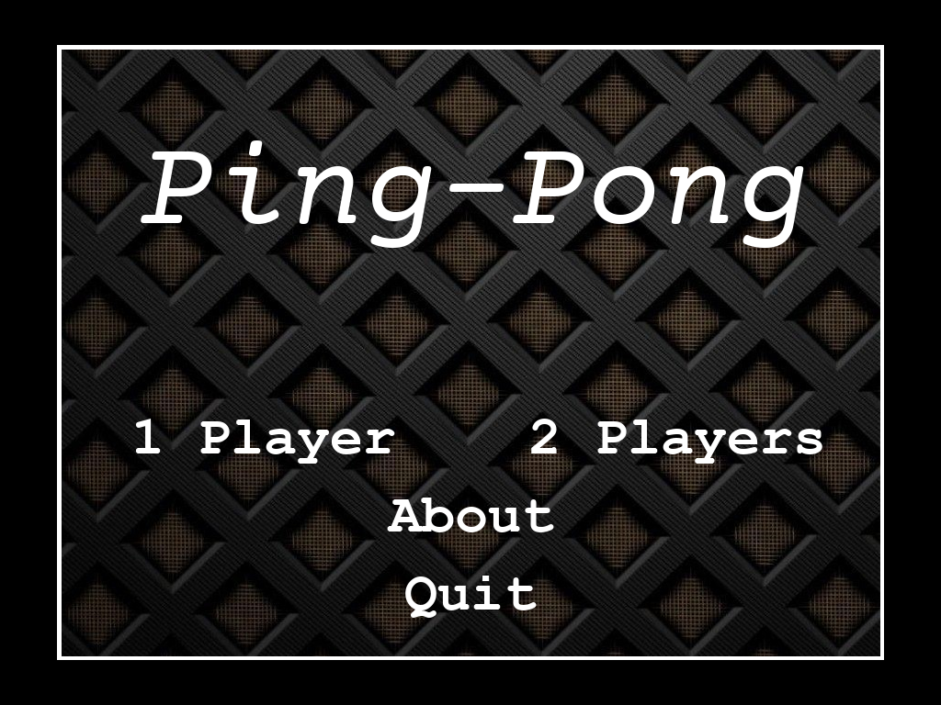

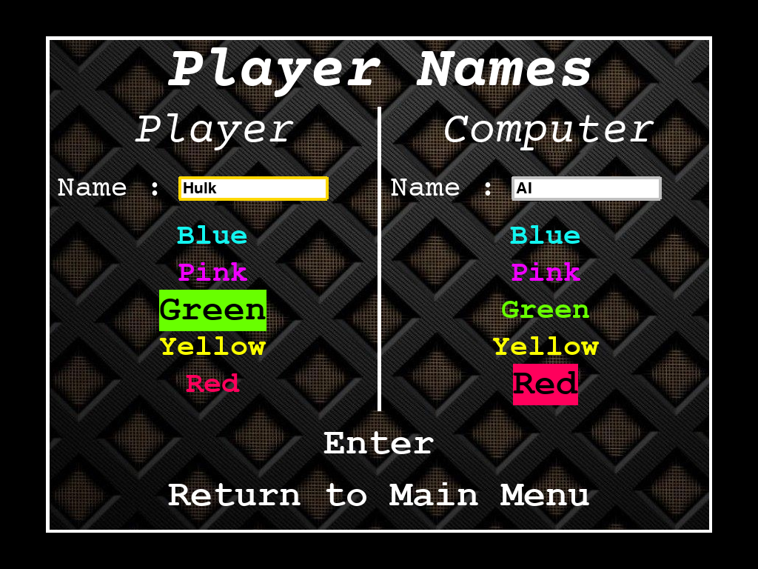

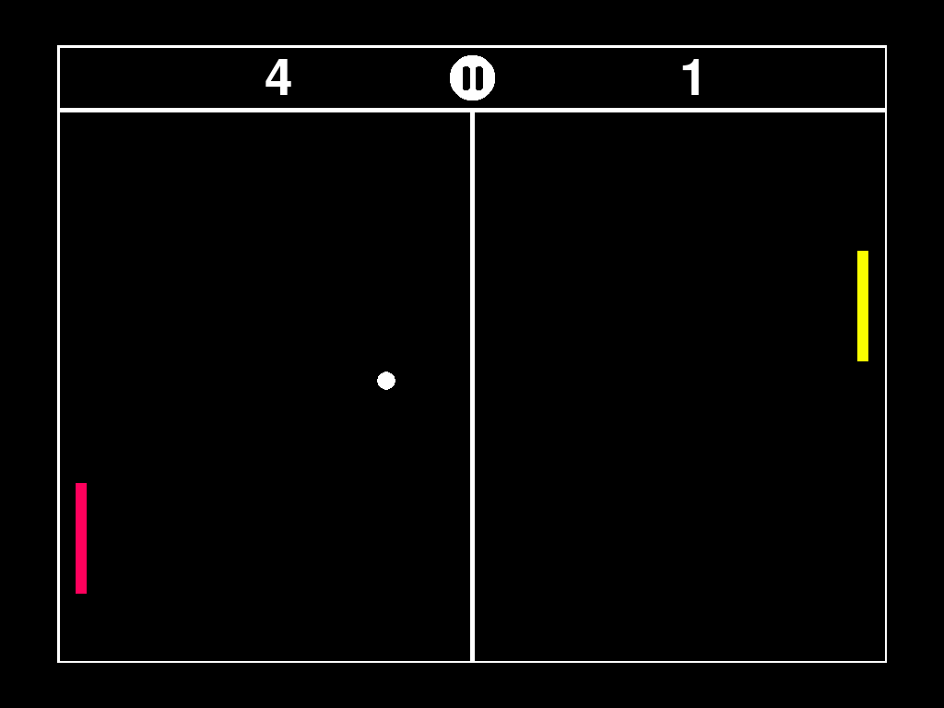

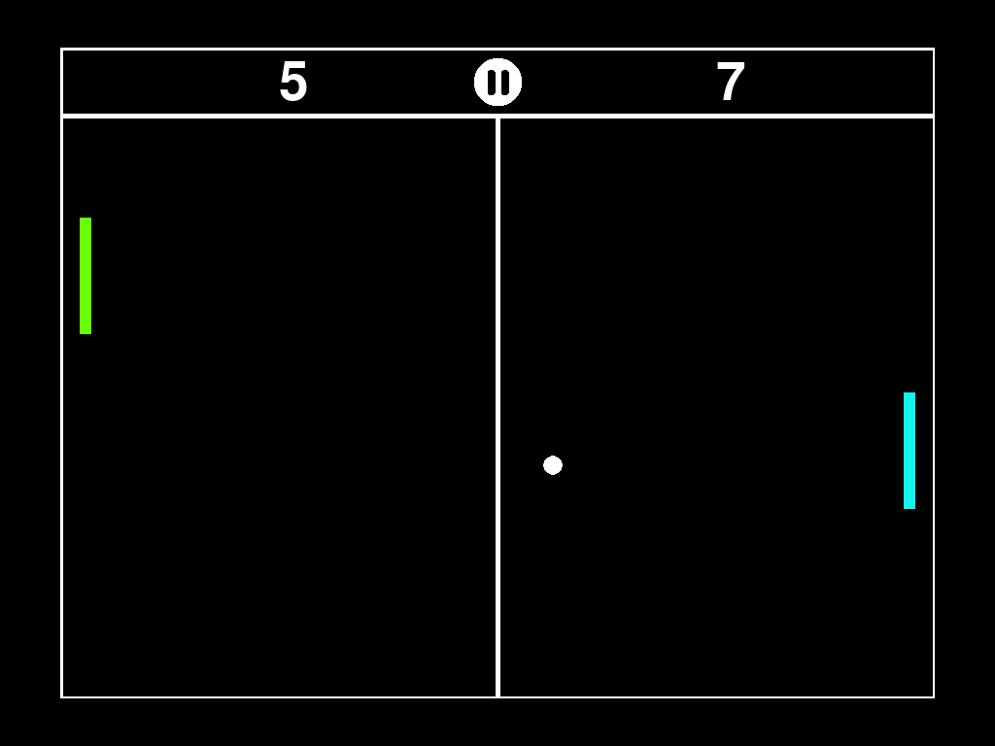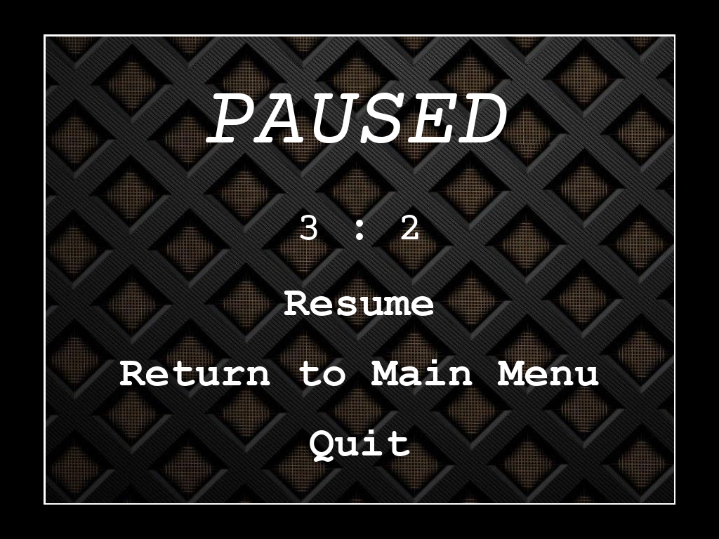

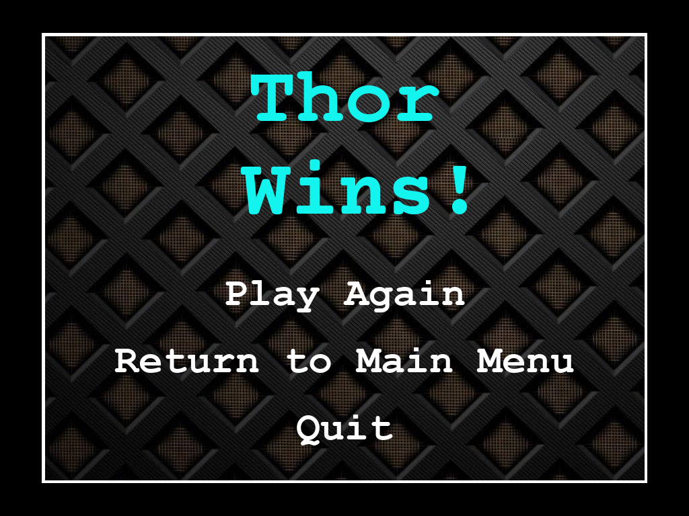

***✽ Database table where the games played are saved with their details✽***

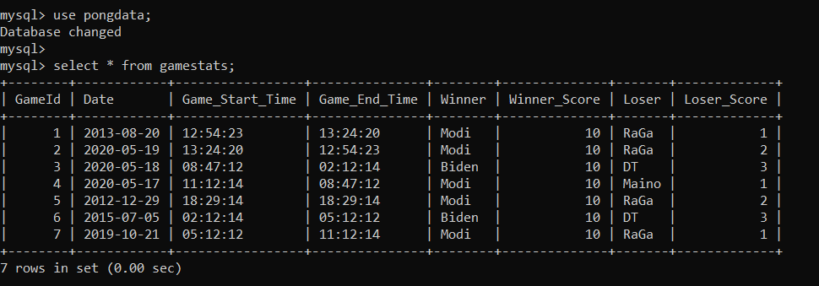

***Limitations***

* The limitations of the project are :

1. No option to change the Theme of the project
2. No option to turn off the sounds
3. The project screen cannot be resized
4. Joysticks not supported
5. No settings screen present
6. No other game modes like Infinite Play, Timed Play, etc.

***Bibliography***

1. NCERT Class-XI Computer Science Textbook
2. NCERT Class-XII Computer Science Textbook
3. <https://www.pygame.org/docs/>
4. <https://docs.python.org/3/>
5. <https://www.geeksforgeeks.org/>
6. <https://pythonprogramming.net/pygame-python-3-part-1-intro/>